Language Arts
Word Play: Alphabet Slate Using Etoys
Second-Third Grade Levels

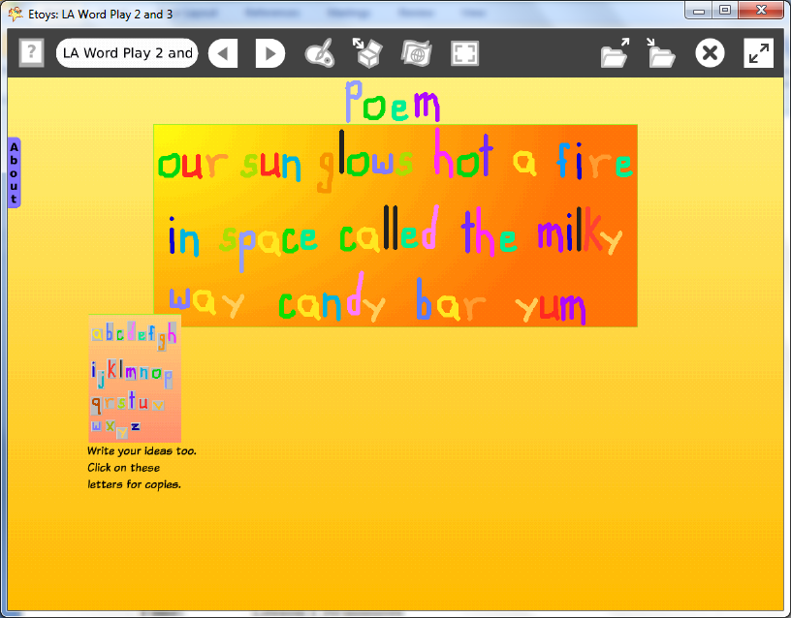

Introduction: | This lesson uses alphabet letter slates drawn by students in a previous project to write a Haiku. If students use a letter slate they made in an earlier grade they will enjoy seeing work they did when they were younger; this memory of their younger self brings a smile.
Topic: | Students build fluency by writing. Writing is a formal style such as a Haiku poem adds value and a level of difficulty by requiring forming ideas and finding words and counting syllables to meet the requirements of the strict form and style.  Students play with letters, words, spacing and patterns using their Etoys alphabet to create a poem and a setting that enhances the imagery of the text.
Subject: | Language Arts
Time: | Lesson 1 two lab periods
Description: | Students write a haiku using the alphabet letters they made in an earlier year in school. Modern English haiku have three or fewer lines with 17 syllables in total.
Vocabulary: | letters, consonants, vowels, syllables, haiku, letters, consonants, vowels, syllables, combinations, combine, sort, show, groups, patterns, same, different, size, small, large,
Evaluation Criteria: | Creates a haiku poem  Counts syllables accurately  Positions words and lines to create deliberate effects  Spells familiar and new words  Can open Etoys to ‘Find’ projects from a previous year  Modifies a playfield to enhance the mood and subject of the poem  Knows how to Publish As
Teacher Information:  Etoys Quick Guides: Click the question mark in  Etoys to open the set of tutorials about basic tools and techniques. | Etoys Quick Guides: Click the question mark in  Etoys to open the set of tutorials about basic tools and techniques.  Use Etoys Quick Guides if the lesson mentions unfamiliar tools or techniques. Give students time to read them too.
Goals: | Students work independently to write a haiku using the modern English form of no more than three lines with a total of 17 syllables in the whole poem.  The subject of the poem could be selected to extend ideas from lessons in science or math, or a story the class knows, or about an event from yesterday or tomorrow.
Lesson 1:  Navigator Bar: Keep Find Projects  Halo Handles: Move and Pick Up  Halo Handles:  Viewer  Navigator Bar: Keep/ Find Projects | Open letter slates that are already created.  Do not change the letters; just use them as they are to write a poem in a style called haiku.  The poem may have two or three lines but no more than three lines.  The syllable count must be exactly 17 syllables for the whole poem; exactly 17 syllables.  Put the poem on a Playfield from Supplies.  Change the color and border to enhance the mood and subject of the haiku.  Click and hold down on Publish it; choose ‘Publish As’ and type a new name for the project. ‘katehaikufeb07’. This will save the poem as one project and the alphabet on playfield will remain as it was when it was opened.
Extend Lesson 1 | Create additional projects: haikus, short poems, sayings, mottos, or proverbs. Examples:  No minute lost ever comes again.  Use it up, wear it out; make it do or, do without.  All that glitters is not gold.
Student Information: | Show an example project or let students use letters slates already made from www.squeakcmi.org
Standards: | Language Arts State Goals  Second Grade Reading  1 A.1a Apply word analysis skills (e.g., phonics, word patterns to recognize new words.  Second Grade Writing  3 A.1 Construct complete sentences, which demonstrate subject/verb agreement; appropriate capitalization and punctuation; correct spelling of appropriate, high frequency words; and appropriate use of the eight parts of speech. During shared and independent writing, the student will:  Generate topics for poetry  Compose poetry  Write expository pieces  Third Grade Reading  1B1b Identify genres (forms and purposes) of fiction, nonfiction, poetry and electronic literacy forms.  Third Grade Writing  3A1 Construct complete sentences which demonstrate subject/ verb agreement; appropriate capitalization and punctuation; correct spelling of appropriate, high frequency words; and appropriate use of the eight parts of speech.  National Educational Technology Standards (NETS)  1. Basic operations and concepts  Students are proficient in the use of technology.  3. Technology productivity tools  Students use technology tools to enhance learning, increase productivity, and promote creativity.  Students use productivity tools to collaborate in constructing technology-enhanced models, prepare publications, and produce other creative works
Resources: | Etoys Help Quick Guides: Open Etoys and click the question mark in the Navigator Bar to open a set of interactive tutorials that introduce basic tools and techniques.  EtoysIllinois.org for projects, tutorials, and lesson plans  Squeakland.org Etoys software
kh
April 8, 2012

